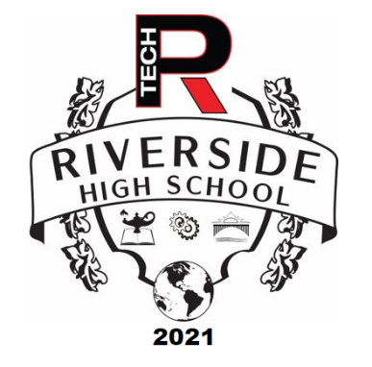

Summer Enrichment Programs

Riverside High School will be offering several summer enrichment programs from August 23-26, 2021, 9am-12pm. Students interested in participating should read the course descriptions below and complete the Teams form for the program they wish to attend. All classes will take place in-person at various locations throughout Yonkers. Students are expected meet their teacher at the program location each day. Students should also bring a snack and a drink daily. Space is limited to 20 students per course and masks are mandatory.

The registration link is located on the Riverside High School Homepage under the P-Tech Summer Enrichment Programs Tab

<https://www.yonkerspublicschools.org/riverside>

Course Descriptions

Book Club:

Teacher: Ms. Stella Quarshie

Location: Tibbetts Brook Park

355 Midland Ave. Yonkers, NY 10704

Dates: August 23rd-26th, 2021

Time: 9:00am-12:00pm

Course Description: Students will discuss popular, thought-provoking, young adult novel, Dear Martin, in Tibbetts Brook Park. In **Dear Martin**, Nic Stone demonstrates how beneficial it is for people facing discrimination to have supportive relationships. Searching for guidance, Justice addresses his diary entries to Dr. **Martin** Luther King, Jr., wanting to fortify himself against the hatred and insensitivity all around him by emulating Dr. King. Teacher will lead discussion with guided questions. Each session will end with a journal entry, picnic, and recreational activity.

Citizen Science:

Teacher: Ms. Kelly Jakab-Muller

Location: Sarah Lawrence College Center for the Urban River at Beczak (SLC CURB)

35 Alexander Street, Yonkers, NY 10701

Dates: August 23rd-26th, 2021

Time: 9:00am-12:00pm

Course Description: Students will work as Citizen Scientists to collect and analyze water samples, aquatic life and plants to gain a better understanding about the Hudson River Estuary and the importance of protecting and preserving our local ecosystem. Students will also participate in high school orientation activities and get a jump start on the Academic and Professional Power Skills necessary to be successful throughout high school, college and career.

Life Drawing:

Teacher: Ms. Kelly Hasso

Location: Yonkers Public Library- Riverfront Library

1 Larkin Center, Yonkers, NY 10701

Dates: August 23rd-26th, 2021

Time: 9:00am-12:00pm

Course Description: Students will work as artists, architects and engineers to create drawings from life by using space, relativity and measurements. Rather than tracing a picture, life drawing allows the artist to see the world from a different perspective, while drawing objects and people right in front of you. Life drawings helps students to understand space and reasoning to portray life and movement on 2-dimensional paper. Students will learn the drafting, research and revision skills that they will use throughout high school and other life experiences.